Dates to Remember
Thursdays |   7am MUP Prayer meeting in the Church House
Wed 23rd Sep | 10am Hymn-A-Long
Wed 23rd Sep | 6.30pm AGM
Sun 27th Sep | 10am All-Ages Family Service
Sun 27th Sep | World Vision Chosen sponsors reveal after the service
Sat 10th Oct | Leadership Away Day


Church Office Hours: 9am - 12noon, Mon - Fri (excluding public holidays).
‘Prayer Chain’ – Any matters requiring confidential prayer support, can be referred to the Prayer Chain Group. Contact Val Judd or Elaine Oates.
Monday Bible Study – Meets weekly at 2.30pm on Mondays in the church house. See Elaine Oates for more info.
Tuesday Afternoon Bible Study – Meets weekly at 1.30pm in the Church House (but not in school holidays). Contact Maureen Wilson for more info.
‘Men’s Group’ – Meets weekly on Tuesdays at 7.30am, currently at Noel Dunn’s place. Contact John Hawksworth for more info.
‘Womens Lunch Study Group’ – Meets fortnightly on Thursdays at 12noon in the Church House. Bring your lunch. Next meeting 15th October. Contact Amanda Lewis for more info.
Women’s ‘Growth Group’ – Meets fortnightly on Thursdays at 1pm at Diane McLean’s. Next meeting 15th October. Contact Diane McLean for more info.

“The manger was the first king-sized bed.” - Unknown

Giving/Tithing - If you wish to tithe or make a donation to Mangapapa Church, our account number is: Mangapapa Church, 03-0638-0381084-00. Please make sure you say ‘tithe’ or ‘donation’ in the reference. If you would prefer to give using our ‘Envelope’ system, then see Jenny Phin who will set you up with envelopes allocated to you.
 | Today | Next Sunday 27th September
Greeters | J & L Hawksworth | M Raitaukala, I McCoy
Ministry Team | A Russell | A Clement
Cups of Tea | I McCoy, J Paton | N Aston, J McLatchie
AV & Sound | R Theobald / J Holland | Z Cowley / A Russell
Counters | A Radcliffe | A Radcliffe

Sunday 20th September 2026

10am: ‘The Armour Of God’

Ephesians 6:10-18

Leading: Andrew Russell Preaching: Shane Roche

Duty Elder: Andrew Russell

________________________________________________________________________________

Church Leader: Shane Roche E-mail: shane@mup.org.nz

Church Office: Dione Russell 06 867-9604 9am – 12noon
E-mail office@mup.org.nz Website: www.mup.org.nz
Mangapapa Church, PO Box 2146, Gisborne 4040
Elders Team
S Roche: 027 501 6584 S Patrick: 021 047 0795
A Russell: 027 815 1635 Clement: 027 855 5949
________________________________________________________________________________

Kidzspace (4-8yrs) go out with Gill Stevenson this morning.
Matrix (9-14yrs) go out with Anna Alder & Ashley Mountfort.
If you have cold, flu or COVID-19 symptoms, please stay home and don’t share them.

Shane shares the message this morning. He writes …

The Armour of God
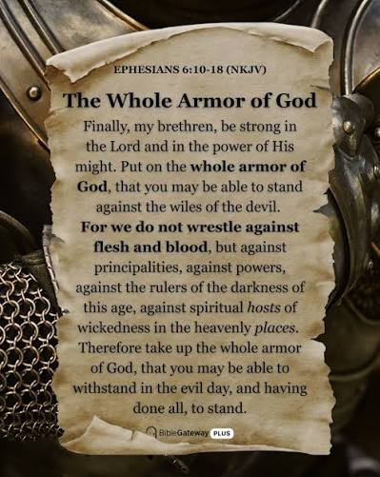
Life can sometimes feel a little heavy. With so much happening around us, it’s easy for worry, negativity and discouragement to creep into our hearts and minds.
But the good news is that God hasn’t left us defenceless!

This Sunday we’ll be looking at Ephesians 6:10–18 and Paul’s encouragement to “put on the full armour of God.” Each piece of the armour reminds us of something God has given us to help protect our hearts, guard our minds and strengthen our faith.
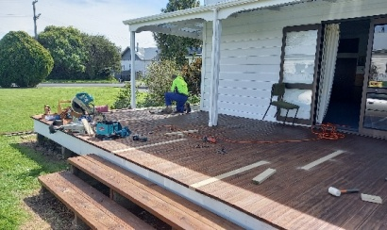
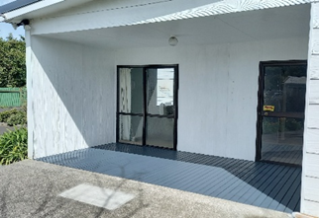
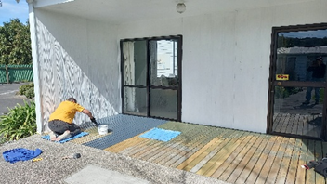
Whatever is happening around us, God has given us what we need to stand firm, hold onto hope and keep our eyes fixed on Jesus.

Key scriptures:
Ephesians 6:10–18; Romans 13:12–14; Proverbs 4:23; Philippians 4:8


For Prayer this week:
- Pray for the AGM this week.
- Pray for Gill
- Pray for Jean
- Praise Ali’s parents have place to live

Please continue to pray for our church family, many of whom are struggling with ongoing health issues


7pm THIS Wednesday 23rd September

The AGM reports are out and can be collected from the church foyer. Please take a copy and read it before the meeting, as these will be taken as read.
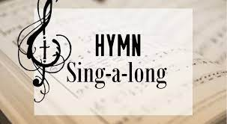
Our Next Hymn Sing-A-Long – Will be at 10am on Wednesday 23rd September, here at MUP. Come and join in a cuppa and singing some of your favourite hymns. All welcome.

World Vision Chosen Sponsors – On Sunday 27th September we will have a representative from World Vision here, with the envelopes from the children choosing a sponsor. So, for those of you who put your hand up to sponsor a child and had your photo taken, you will be able to find out after the service which child chose you.

Assets & Finance Team Update – Over the past few weeks there has been some great voluntary maintenance work done to repair and rejuvenate our Church Property assets. Mike Sharp installed new security night lights at the main entrance, Mike Tombleson has completely rebuilt the access ramp to the School House from the Carpark, solution cleaned & water blasted much of the main buildings and decks, replaced broken decking boards, installed new fire extinguishers & more. We have also commenced painting & re-staining the various decks we have. We are looking to involve more folk in a ‘Working Bee’ one Saturday morning later in October.

Diane's Message on 'Forgiveness' last Sunday - We did record this message and it is available to view for MUP Church members but not publically online. To access, see Dione @ the Church Office and bring a USB for it to be downloaded.


‘God Is Pro-Life’ Youth Rally - These October School Holidays a team from Voice For Life is touring Hawkes Bay. If you are in high school, and have questions about pro-life issues, this event is for you! Pizza, games, quizzes – plenty of fun and learning. Sunday 4th October 5.30pm-8.30pm at Alive Church in Leith St. See poster on church noticeboard for more information.


Foodbank – Thank you to those who give to this ministry. Current needs are:
Pasta, 2 Min Noodles, coffee, 500ml cooking oil, canned peas, canned corn, toilet paper, canned fruit, pasta sauce, milk powder

